CIS 8040 Anirudh Chaudhary

Assignment 2 Quan Le

Professor Veda Storey Hao Nguyen

**Question 1 and 2**:

1. Profession - Length of Stay in store Relationship

|  |  |  |  |  |
| --- | --- | --- | --- | --- |
| **Profession/Length of Stay in the store** | **Length of stay in store** |  |  |  |
| **Profession** | **<15min** | **>30min** | **15-30min** | **Grand Total** |
| professor | 16 | 1 | 3 | 20 |
| student | 6 | 6 | 8 | 20 |
| **Grand Total** | **22** | **7** | **11** | **40** |

Based on the above pivot table on count of customers regarding to their professions and length of stay, we can tell customers who are professors tends to only remain in store less than 15 minutes comparing to customers who are students.

**Recommendation**:

Based on the identified pattern, in order to lure professors to spend more time in the coffee shop, special and quiet sitting sections can be introduced. In these sections, professors can relax, read, prepare lecture notes, continue their research and do many more things along with a cup of coffee and some snacks. The longer time customers spend in the shop, more likely for them to spend some extra money making the shop more profitable.

1. Profession-Income-Coffee Size Relationship

|  |  |  |  |  |
| --- | --- | --- | --- | --- |
| **Profession/Income/Coffee Size** | **Coffee Size** |  |  |  |
| **Profession/Income** | **grande** | **tall** | **venti** | **Grand Total** |
| **professor** | **5** | **7** | **8** | **20** |
| >50K | 4 | 7 | 8 | 19 |
| 30-50K | 1 |  |  | 1 |
| **student** | **6** | **7** | **7** | **20** |
| <30K | 4 | 5 | 5 | 14 |
| >50K |  | 1 | 1 | 2 |
| 30-50K | 2 | 1 | 1 | 4 |
| **Grand Total** | **11** | **14** | **15** | **40** |

Based on the above pivot table on count of customers regarding to their professions and Income and Coffee Size, we can tell customers who has income > 50K buy either tall or venti size. Professors are mostly customers who have income higher than 50 K. Income of students doesn’t affect their preferences of coffee size, only income of professors affects preference of coffee size.

**Recommendation**:

Based on the identified pattern, the coffee shop can increase the price of the coffee for sizes tall and venti for non-student customers. This segment mainly consists of professors whose income is more than 50k, therefore, sales will not be get impacted and profit margins will increase. Also, student discount can be introduced as mostly students who have income less than 30k order coffee irrespective of any size preference. Making coffee more affordable to students will increase customer satisfaction, thereby, increasing the footfall per day which will ultimately increase the sales.

1. Income-Buy Pastry Size Relationship

|  |  |  |  |  |
| --- | --- | --- | --- | --- |
| **Income/Pastry** | **Income** |  |  |  |
| **Buy Pastry?** | **<30K** | **>50K** | **30-50K** | **Grand Total** |
| no | 9 | 11 | 3 | 23 |
| yes | 5 | 10 | 2 | 17 |
| **Grand Total** | **14** | **21** | **5** | **40** |

Based on the above pivot table on count of customers regarding to their income and buy pastry option, customers who have income <30K will likely not to buy pastry along with coffee. Income from 30K or above will not affect the buying pastry decision of customers

**Recommendation**:

From the pattern identified, the data makes it clear that customers with income less than 30k do not tend to spend on pastry. So, the lower income group can be lured into buying pastry by introducing some pastry variants which are a bit cheaper than the ones currently available. This will attract the customers with income less than 30k to spend a bit more and the profit of the coffee shop can be increased.

1. Marital status – Time of store visit Relationship

|  |  |  |  |
| --- | --- | --- | --- |
| **Marital Status/Time of store visit** | **Time of store visit** |  |  |
| **Marital Status** | **am** | **pm** | **Grand Total** |
| married | 14 | 8 | 22 |
| single | 6 | 12 | 18 |
| **Grand Total** | **20** | **20** | **40** |

Based on the above pivot table on count of customers regarding to marital status and time of store visit, customers who already married tend to visit store in the AM while customers who are single tend to visit the store in the PM.

**Recommendation:**

Based on the identified pattern, since customers who are single tend to come more during pm hours of the day, the coffee shop can add facilities like pool table, foosball table and some board games. These introductions will stimulate socializing among customers and help them rejuvenate after their work. Single customers will definitely get attracted by these changes as they seek places like these to hang out in their free time. This will increase customer retention, thereby increasing profits on the longer run.

1. Hair Color – Coffee Size Relationship

|  |  |  |  |  |  |
| --- | --- | --- | --- | --- | --- |
| **Hair Color / Coffee Size** | **Hair Color** |  |  |  |  |
| **Coffee Size** | **blonde** | **brown** | **gray** | **red** | **Grand Total** |
| grande | 1 | 7 | 1 | 2 | 11 |
| tall | 3 | 10 | 1 |  | 14 |
| venti | 5 | 3 | 6 | 1 | 15 |
| **Grand Total** | **9** | **20** | **8** | **3** | **40** |

Based on the above pivot table on count of customers regarding to hair color and coffee size, customers who have blonde and gray hair tend to order venti size while customers who have brown hair tend to order either grande or tall size. Also, we can see from this pivot table that half of customers of the store has brown hair.

**Recommendation:**

No change can be recommended to the coffee shop on the basis of this pattern as it is sheer coincidence that a customer with specific hair color buys which size of coffee. From the hair color of an individual nothing relevant can be inferred which can be used to increase the profit margins of the coffee shop.

**Question 3**:

We have added and populated an additional column, namely, “Hours of Working”, and it represents how many hours each customer works per day. We predicted that customers with a long working time tend to purchase larger amount of coffee; to understand the customers better, this additional attribute will help us see the trend that specific group of customers.

The number of hours range from 6 hours to 12 hours. We wanted to see how the differences in the number of hours per day from the customers with different incomes will determine the size of coffee that they would get. In addition, we wanted to see which income groups will more likely splurge their money on coffee based on their working hours. The table below shows that Professor with high income (>50K) who works for 8 hours per day tend to get coffee. Majority of them get Grande or Venti size. In contrast, students with low income (<30K) tends to get Grande or Tall size.

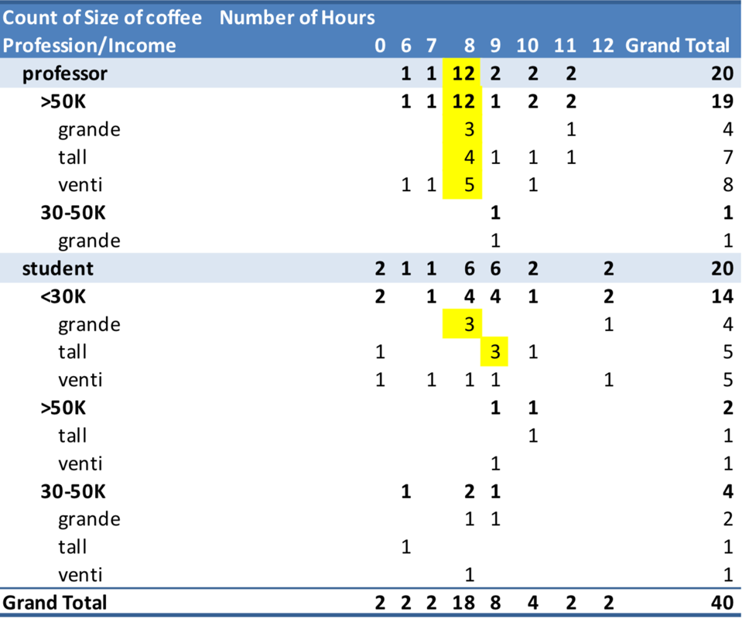

To make more profit, we can also use the Hours of Working and compare with time of store visit and size of coffee, so we can allocate when is the best time that most group of 6 hours, for example, would get more Venti and so on.